内部资料
注意保密

- ata field

Invoice Submission
- Invoice submission UI

- Data field
SELLER INFORMATION | *
Name of your Company | * | System fills in automaticly name of seller
Represented by | * | drop down list:  Mr, Mrs, Ms, Miss  drop down list:  The names of seller's authorized users
DEBTOR INFORMATION | *
Name of debtor | * | drop down list sorted by alphabetical order:  Debtors predefined list
Address | * | Separate fields for: Street, No, City, Province, Country, Code.
Business registration no | *
Tax code | *
FINANCING INFORMATION | *
Sticker ID | * | Type in: 6 digits number
VAT Invoice Number | *
Invoice issuance date | * | Calendar predefined
Invoice amount | * | Let SME key in
Object of invoice | * | Drop down list: TBD  Recommendation: Services delivery; Goods delivery - perishable; Goods delivery - nonperishable
Due date according to the contract | * | Calendar predefined
Expected Payment Date | * | Calendar predefined
Remaining maturity term | * | To be automatically calculated by the system as number of days between current date (invoice upload date) and Expected Payment Date.
READY TO SELL | *
Advance | * | Percentage box
Interest | * | Percentage box

- Documents upload
- Scan of invoice (Mandatory);
- Scan of contract (Mandatory);
- Delivery confirmation (Mandatory);
- The acknowledgement from the debtor (Mandatory for high-risk sellers)

• Button: Submit

- Invoice submission confirmation UI

Show the sellers all the invoice information that they have submitted

- Data field
Same as invoice submission page for the seller to confirm

- Documents upload
Same as invoice submission page for the seller to confirm

- Legal Conditions
A box containing the legal conditions, at the end the seller and check the box to accept these conditions

• Button: Confirm; Modify

- Invoice submission Completed UI

Show the following message:

“Your Invoice submission has been completed and is under approval. You will receive the approval result within maximum 2 days.”

• Button: Homepage

Auction for Buyers
- Auction for Buyers UI

The interface should show the invoices in the market for auction right now. Each row corresponds to one invoice. The each column specifies the detail of the invoice. The column detail that should be included are as follows:

Invoice number; Auction closure date; invoice maturity date; Current best interest rate; Current best financing rate; Ready-to-sell interest rate; Ready-to-sell financing rate

For each row, the seller should be able to click and see the details so that they can place a bid. The example of the structure is shown below:

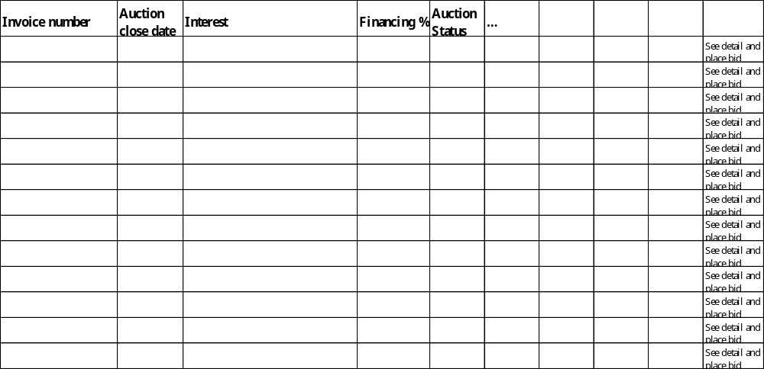

There must be filters for investors to find the invoices that they want. For Auction close date; invoice maturity date; interest rate; financing rate, the filters should be ‘<’, ‘>’, ‘=’. The filter should allow the filtering of multiple conditions at the same time.

- Open Auction Detail for Buyers UI
After the buyers click an open invoice for auction, they need to be able to see the detail of that invoice. The fields and information that need to be included in the UI, please see as below. All the information below need to be included. The layout of the interface below is just for reference. The UI designer can freely designer the interface.

At the upper left corner, the 3 things that the sellers can see are:
− Invoice ID
− Industry of Debtor
− Size of Debtor

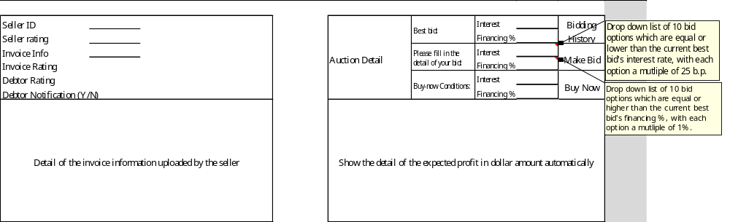

The two boxes that are marked with comments are drop-down boxes. “Bidding history”, “Make Bid” and “Accept ready-to-sell” are buttons. All others are for read only.

All the fields that need to be shown in the expected profit calculation are as follows:

Expected Amount of Interest Received; Expected Amount of Financing; Transaction Fees

- Bidding History UI
After the buyers click “bidding history”, the buyers can see the past bids placed on that invoice. It should be a pop-up window, or the a new tab should be opened. The most recent one should be at the top. The detail of the content please refer to below. The layout of the interface below is just for reference. The UI designer can freely designer the interface.

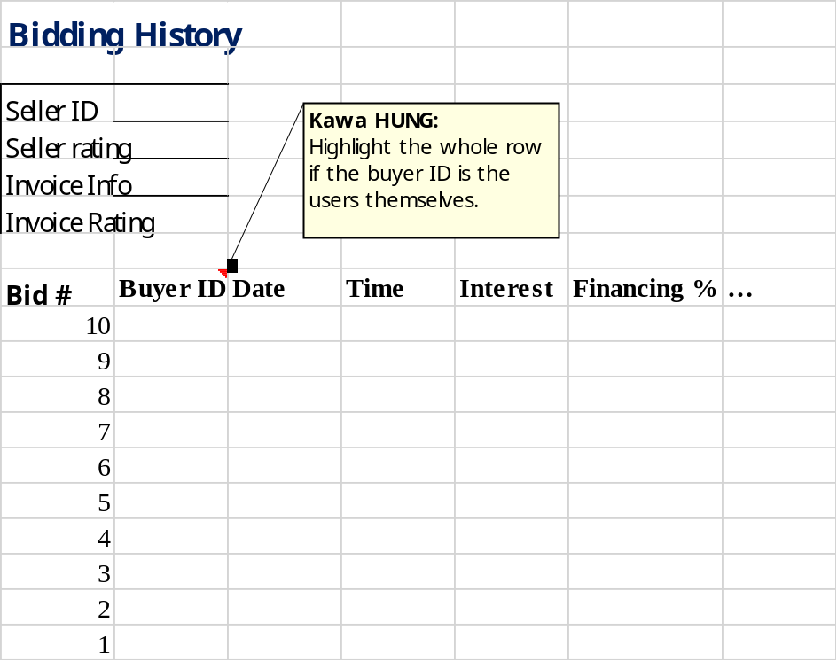

- Confirmation of Accepting Ready-to-sell conditions UI
After the buyers click “Accept Ready-to-sell”, they need to be able to confirm the interest rate and financing rate that they are accepting. All the fields that need to be shown are as follows:

Interest Rate; Financing Rate; Expected Amount of Interest Received; Expected Amount of Financing; Transaction Fees

Button: Yes; No

- Confirmation of Bidding UI
After the buyers click “Make Bid”, they need to be able to confirm the interest rate and financing rate that they are offering. All the fields that need to be shown are as follows:

Interest Rate; Financing Rate; Expected Amount of Interest Received; Expected Amount of Financing; Transaction Fees

Button: Yes; No

- Complete of Accepting Ready-to-sell conditions UI

Show the following message:

“You have successfully purchased the invoice.”

Button: Back to Homepage

- Complete of bidding conditions UI

Show the following message:

“You have successfully placed a bid to the invoice.”

Button: Back to Homepage

- Closed Auction Detail for Buyers UI
After the buyers click an invoice closed for auction, they need to be able to see the detail of that invoice. The fields and information that need to be included in the UI, please refer to “Open Auction Details for Buyers”. The layout of the interface below is just for reference. The UI designer can freely designer the interface.

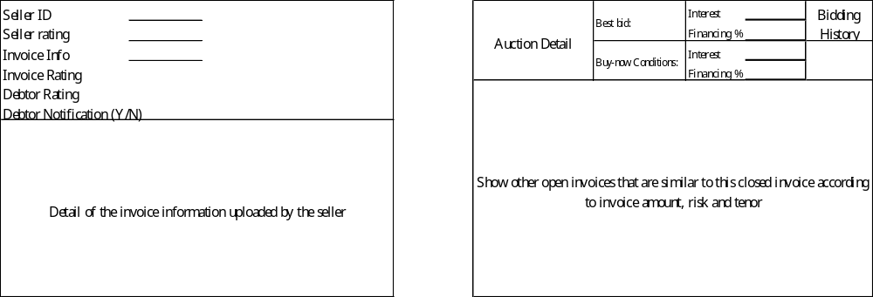

The interface is similar to “Open Auction Detail for Buyers UI”, except that it contains only “Bidding History” without the options for bidding and buy. The space at the lower-right corner, instead of calculating the profit, will show 3-5 invoices open for auction that are similar to the one that they are looking. It should show the invoice amount and tenor.

- My Bids for Buyers UI

This UI is for buyers to keep track of the bids that they have placed. The interface should be similar to the “Auction for Buyers UI”, but here they can only see invoices that they have bid. The filters should be the same as that part as well. The column detail are similar as well, with one more addition:

Invoice number; Auction close date; invoice maturity date; interest rate; financing rate; auction status; Status of Your Bid

The table below is for reference:
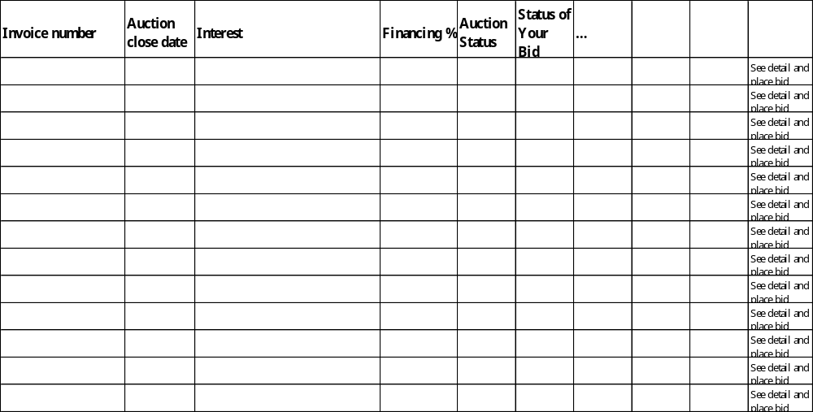

For closed auctions, the status will be “Accepted” or “Not Accepted”. For open auctions, the status should be “Best Bid” or “Not Best Bid”. The invoices with the status “Best Bid” and “Not Best Bid” should be highlighted in different colors, so that the buyers can easily see which invoices require follow-up bids to make their bid the ‘best’ one.

Auction for Sellers
- Invoice in the Market for sellers UI

This UI is for sellers to reference the invoices that are on the market.
This UI should be exactly the same as “Auction for Buyers UI”, except that the button of clicking to see the details “See Detail and Place Bid” should not be available for sellers, because we don’t allow them to see other people’s invoices and place bids.

- My invoices UI

This UI is for buyers to keep track of their own invoices uploaded. The interface should be similar to the “Auction for Buyers UI”, but here they can only see invoices that they have uploaded by themselves. The filters should be the same as that part as well. The column detail are similar as well, with one more addition:

Invoice number; Auction close date; invoice maturity date; interest rate; financing rate; Ready-to-sell interest rate; Ready-to-sell financing rate; auction status; Status of Your Invoice

“My Invoices” page should be the first layer. With second layers as follows:

My Invoices
Invoices Under Approval
Invoices In Auction
Invoices After Auction

The layout of these 4 pages should be the same.

At the end of each row, there should be a button for the sellers to “See Details and Accept Offer”.

The “Status of Your Invoices” status should at least contain: Under Approval; In Auction; Auction Closed; Disbursed.

- Open Auction Invoice Detail for Sellers UI

After the sellers click “See Details and Accept Offer”, for auctions that are with the status “In Auction”, the seller should be able to see the bidding history in a table with the following columns: Buyer ID; Date of Bid; Time of Bid; Auction close date; invoice maturity date; interest rate; financing rate.

The most recent bids should be placed at the top, and there should be a button “Accept Offer” besides the most current bid, so the the sellers can accept the most current and the best bid.

The page should also contain the details of this particular invoice that the sellers have uploaded.

- Pre-Auction/Post-Auction Invoice Detail for Sellers UI
This UI should be very similar to the “Open Auction Invoice Detail for Sellers UI”, except that the “Accept Offer” button should not be available, because either the invoice is under approval, or the auction process has been closed already.

- Confirmation of Accepting Offer UI
After the seller click “Accept Offer”, they need to be able to confirm the interest rate and financing rate that they are accepting. All the fields that need to be shown are as follows:

Interest Rate; Financing Rate; Expected Amount of Interest Charged; Expected Amount of Financing; Transaction Fees

Button: Yes; No

- Complete of Accepting Offer UI

After the seller has confirmed to sell the invoice or some one has accepted the ready-to-sell conditions, then show the following message:

“You have successfully sold your invoice.”

Button: Back to Homepage

